AI-MAS Winter Olympics
2013

Document type: CQ3 Tutorial
Date: 17.12.2012

Crafting Quest 3 - Tutorial

Introduction
Crafting Quest is a turn-based strategy game with maximum 4 players. This tutorial describes how to run both the client and server software. It also shows how to build the jar archive that you will have to submit for the competition. This tutorial is based on the Eclipse IDE.

Preconditions
The following assumes that you already have your Eclipse working environment set up.

Running the client

In order to run your solution, you should create a new Java project, setting the folder extracted from the cqclient.zip archive as default location (uncheck Use default location and set the Location field) Set your desired name for the project in the Project Name field and press Finish.
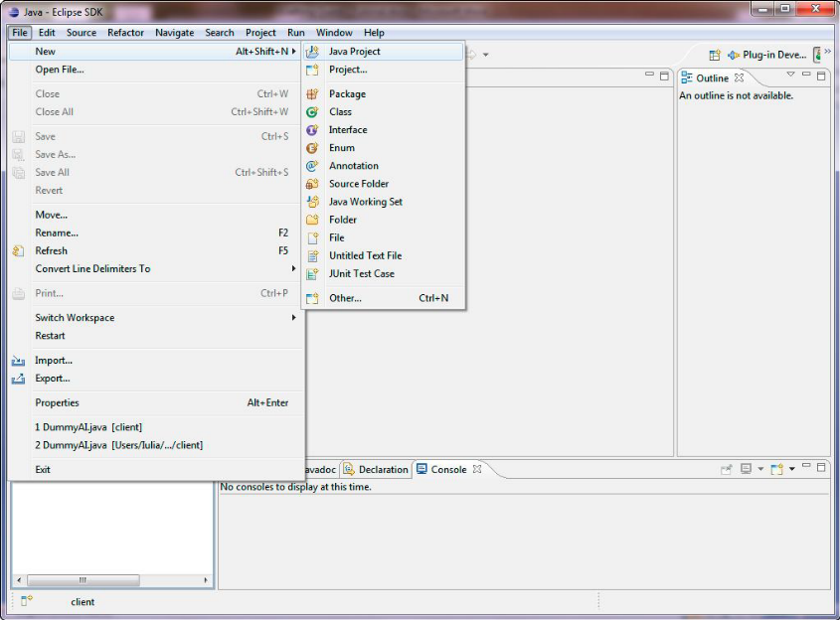

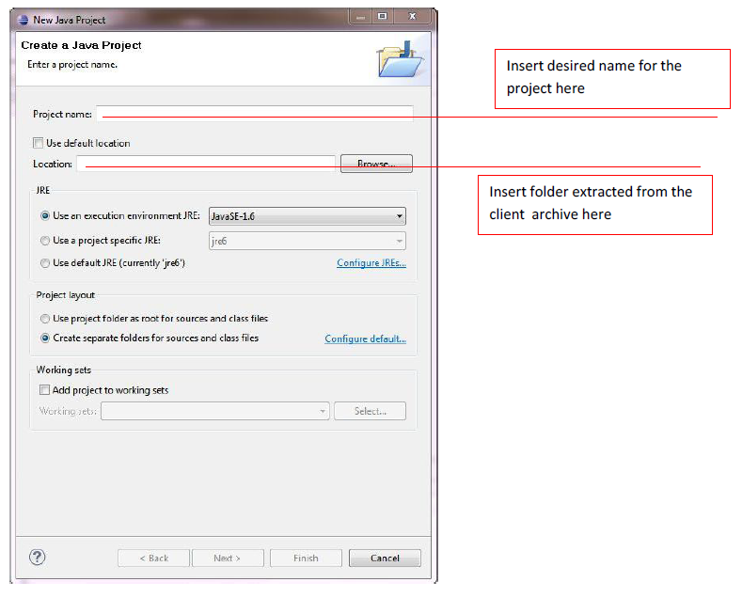

If the following libraries:
- cajo.jar
- cqclient.jar
do not appear in the project (select project, right mouse click and select properties, then go to the Java Build Path tab and look in the list for them).

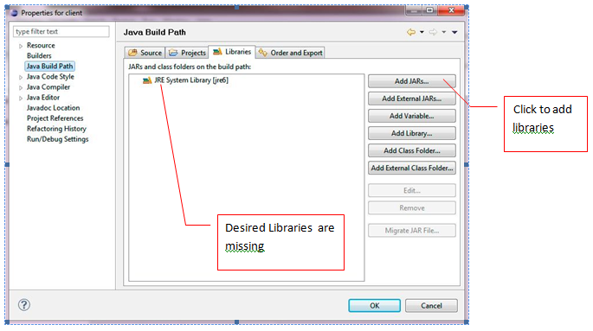
Otherwise, select your project, right mouse click and select properties. In the Java Build Path tab, under libraries select Add JARs and choose the three libraries from the lib folder. Hit Ok twice to complete(Jar Selection and Properties).
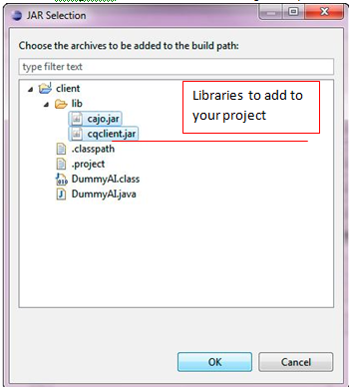
NOTE: The client SDK ships with the javadoc documentation for the client API. It is contained in the cqclient/doc folder that you can access after unzipping cqclient.zip. To enable documentation for the client API in Eclipse, follow the steps in this short tutorial: http://www.cs.laurentian.ca/aaron/cosc1047/eclipse-tutorials/javadoc-tutorial.html#javadoc2, where the target jar file is client.jar and the javadoc folder is cqclient/doc.

In order to run the client (as an Application), you should set a RunConfiguration for your project (Run → Run Configurations or right click on project and select Run → Run Configurations)
It should have the following settings:
- org.aimas.craftingquest.user.MainAI must be set as Main class
- Insert these arguments:
  - ClassName – name of the class containing your solution
  - Host – probably localhost for your client
  - Port – must be identical to the server’s port
  - ServerName – the name set for the server as a run argument (See Running the Server)
  - ServerKey – a secret key defined in the secrets file from the server’s archive

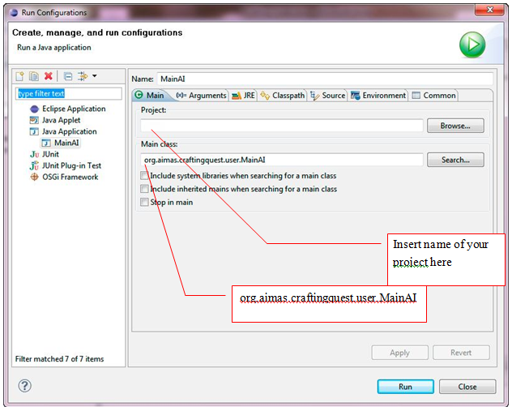
The image below contains the arguments for running our Dummy solution. During the competition, those parameters will be set automatically by scripts responsible for launching the game.
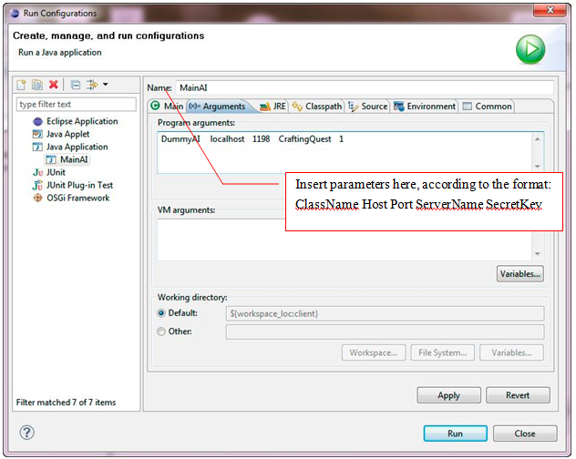
Click Run only after you have unzipped and started the server.

Running the Server

To run the server use the following command:
java -jar cqserver.jar [ServerName, Port, Secrets_file_name]
having the parameters defined above. The parameters in square brackets are optional. Default values exist for them.

The default values for these parameters are:
- serverName: CraftingQuest
- Port: 1198
- Secrets_file_name:secrets.txt
If you do choose to change the values for the server parameters you have to specify all three of them, otherwise the server will signal an error.
If you want to enable the GUI you have to add an additional parameter to the above command, namely:
java –Dgui=true -jar cqserver.jar [ServerName, Port, Secrets_file_name]

Secrets.txt is a text file having the following format:
- The first line contains an integer n specifying the number of clients that must connect to the server
- The next n lines each contain an integer specifying a secret key
The secret keys (integers) are used for identification and security reasons and will be automatically generated by scripts running a game during the competition.

NOTE: The game configuration shipped with the SDK (specified in the GamePolicy.xml file), provides for a number of 2 players on the map. If you wish to modify this setting to include up to 4 players (the maximum allowed) you can edit the GamePolicy.xml file and alter the parameter <nrPlayers> to the value you desire. Please make sure to reflect the change in the file Secrets.txt as well, by defining n secret keys (where n is the number of players you have set in GamePolicy.xml).

Setting custom logging configurations

Both client and server archives contain a file named logging.properties which is a log4j properties file, i.e. it gives directives for the way in which messages are logged. The default settings generate a ConsoleAppender which will print messages to System.out. By un-commenting the rest of the directives you can also have the logging mechanism output messages to files called server.log and client.log respectively. Additionally, you can customize the logging.properties file in any way you like to obtain desirable logging configurations. For details about this visit http://logging.apache.org/log4j/1.2/manual.html.

Building the solution needed for submission
Building your solution is done by running the ant build script (clientbuild.xml) included with the client archive (cqclient.zip). Running the script requires that you have the ant utility installed on your system. You can download it from http://ant.apache.org/bindownload.cgi and set it up.
Let’s assume that your project directory looks something like this:
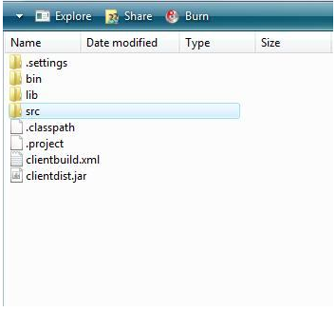
The build script assumes that all your source files lie in the src directory. You must ensure this in order for the script to function properly. If these conditions are met, navigate to the root of your project (where clientbuild.xml resides) and run the following command:
ant -Dmainclass=<your_main_class> -buildfile clientbuild.xml
The output of this command will be a jar archive named clientdist.jar which you will have to submit as your solution for the competition. The parameter <your_main_class> represents the fully-qualified java class name of your solutions’ main class (the one that extends AIThread).
Note: A fully-qualified class name is the name of a java class that includes its package name. Running the above command will also produce a build directory in the project root. After building your jar, you can delete the build directory.

